資多三A 3D造型設計 109年度第1學期期末考
班級：_______學號：____________姓名：___________ 2021.1.13

期中考操作題：100%(使用3ds max 2020)
- 利用3ds max內建的Box幾何體創建角色的雙腳，利用shape的text製作出立體學號、立體姓名，學號當雙手及肩膀，姓名當身體，載創建一個Sphere做成頭型，把這些物件排列成人體外型，如下圖。(50%)
- 加入人體骨架並與模型做蒙皮binding，可調包絡線讓骨頭運動可以帶動相關的模型部位。(30%)
- 請為骨架套一個.bip動作，利用模型包絡線調整模型運動到順暢。(20%)
- 檔案存為”你的學號姓名”，繳交壓縮檔.zip到\\192.168.51.11的”期末考繳交”資料夾。

Ps.或繳交與”3D造型設計”相關主題的Word報告一份也可。

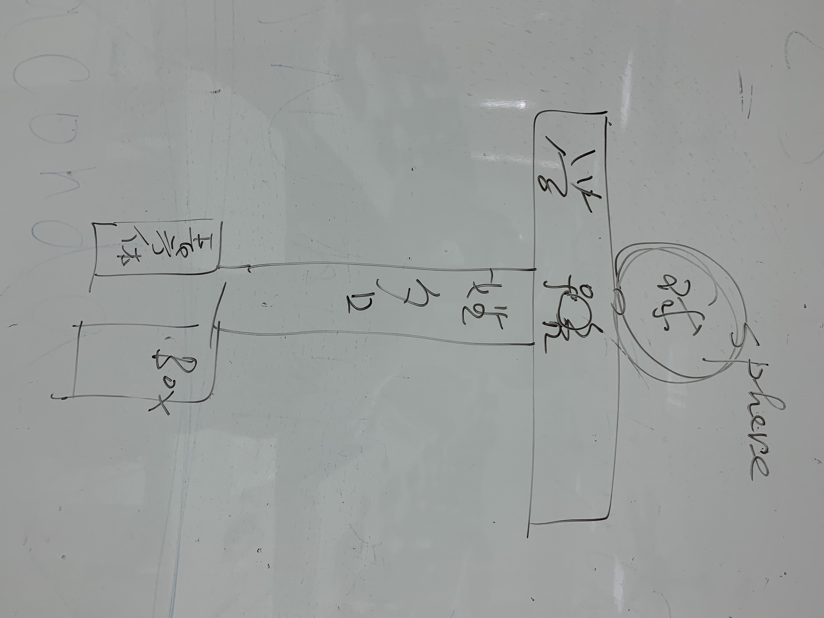

CSMD 3D modeling design 109th semester final exam
Class: _______ Student ID: ____________ Name: ___________ 2021.1.13

Mid-term exam operation questions: 100% (using 3ds max 2020)
1. Use the built-in Box geometry of 3ds max to create the character’s feet, use the text of shape to create a three-dimensional student number, a three-dimensional name, the student number as hands and shoulders, and the name as the body. Create a Sphere to make a head shape and arrange these objects to human body. (50%)
2. Join the human skeleton and make skinning (binding) with the model, and the adjustable envelope allows the bone movement to drive the relevant model parts. (30%)
3. Please set a .bip action for the skeleton, use the model envelope to adjust the model movement to smooth. (20%)
4. Save the file as "Your Student ID Name", and submit the compressed file .zip to the "期末考繳交" folder of \\192.168.51.11.

Ps. or submit a Word report on the subject of "3D modeling design".

